Quiz

Question 1) What is the lambda operator?

->

Question 2) What is a functional interface?

An interface that contains only one abstract method.

Question 3) How do functional interfaces and lambda expressions relate?

Lambda expressions can be used to represent the instance of a functional interface.

Question 4) What are the two general types of lambda expressions?

Single expression and body

Question 5) Show a lambda expression that returns true if a number is between 10 and 20, inclusive. (code snippet)

public class test {

public static void main(String[] args) {

MyTest testing;

int number = 5;

testing = (n) -> (number > 10) & (number < 20);

System.out.println(testing.testing(5));

}

}

Question 6) Create a functional interface that can support the lambda expression you created in question 5. Call the interface MyTest and its abstract method testing( ). <-- code snippet

public interface MyTest {

boolean testing(int n);

}

Question 7) Create a block lambda that computes the factorial of an integer value. Demonstrate its use. (code snippet)

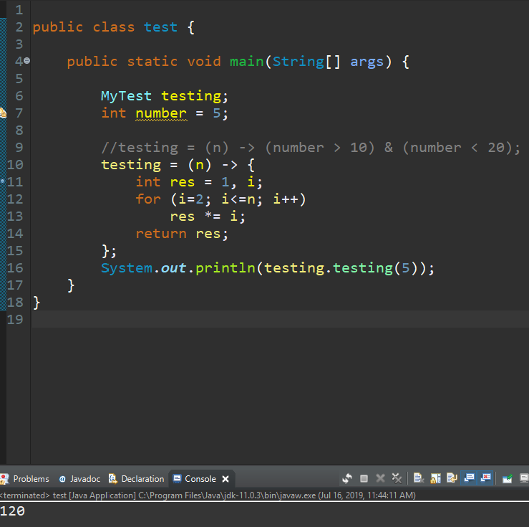

Question 8) Can a lambda expression use a local variable? If so, what constraint must be met?

Yes, but it must be as if it were final or actually be final.

Question 9) If a lambda expression throws a checked exception, the abstract method in the functional interface must have a throws clause that includes that exception. (true or false)

True

Question 10) What is a method reference?

A way to refer to a method without executing it

Question 11) How is a constructor reference specified?

Classname :: new

Question 12) Java defines several predefined functional interfaces in what package?

Java.util.function

Question 13) In computer programming, an anonymous function (function literal, lambda abstraction, or lambda expression) is a function definition that is bound to an identifier (true or false)

False

Question 14) JDK 6 introduces lambda expression (true or false)

False

Question 15) Name at least 5 key benefits of lambda expressions in Java (bullet list)

* Readability
* Code reuse
* Less code
* Enhanced iterative syntax
* Simplified variable scope

Question 16) Can we use generics with lambda expressions?

Yes

Question 17) Lambdas are commonly referred to as: (pick a single choice)

a) closures

b) semantic coding

c) constructor overload

d) passive method

e) all of the above

Question 18) Functional Interface: The keyword modifier ‘abstract’ is required when defining a functional interface as it not implicit (true or false)

False

Question 19) Functional interface are not reusable, only one instance can be created in code (true or false)

False

Question 20) Primitive Data Types are not allowed to be used to define a functional interface (true or false)

False